**Test Plan for My Notes App**

Objectives

Scope

Types of Testing

Environments

Success Criteria

Roles and Responsibilities

Schedule and Milestones

Tools and Equipments

Inclusions

Test Objectives

Modules to test

Exclusion

Text Environment

Test Strategy

Entry and Exit Criteria

Entry Criteria:

Exit Criteria:

Test Execution

Entry Criteria:

Exit Criteria:

Test Closure

Entry Criteria:

Exit Criteria:

Approvals

**Objective**

In this document of the Test Plan for the My Notes App, I aim to ensure the reliability, usability, and performance of core functionalities such as user authentication, note management, search, and profile handling. The app allows users to create, edit, delete, and search notes categorized by type, with a focus on a seamless user experience across devices.

**Technologies Used:**

* Frontend: React
* Backend: Node.js/Express
* Database: PostgreSQL

The testing will verify that all features work as expected, identify defects early, and confirm compatibility with various environments.

**Scope**

The features and functionality of My Notes App that will be tested include:

* User interface (UI) and user experience (UX) across all pages.
* Authentication processes (Login and Register).
* Core note operations (Create, Edit, Delete, Search).
* Dashboard/Home Page navigation and elements.
* Profile management (View, Edit, Change Password).
* Mobile compatibility and responsiveness.

**Types of Testing:**

* Manual testing for functionality and usability.
* Automated testing (where applicable, e.g., regression via scripts).
* Performance testing for load times.
* Accessibility testing (keyboard navigation, screen reader compatibility).

**Environments:**

* Browsers: Chrome, Firefox, Edge.
* Operating Systems: Windows 10.
* Device Types: Desktop, Laptop, Smartphone.

**Success Criteria:**

* 95% test case pass rate.
* Zero critical defects in production-like environments.
* User satisfaction score > 4/5 (post-testing survey).
* All defects resolved within 48 hours for high-priority issues.

**Roles and Responsibilities:**

* **Test Lead:** Overall planning and reporting.
* **Testers:** Execute test cases and report defects.
* **Developers:** Fix defects and verify fixes.
* **Stakeholders:** Approve test plans and review reports.

**Schedule and Milestones:**

* Test Planning: September 4, 2025.
* Test Execution: September 5, 2025 (2 Sprints).
* Defect Resolution: with closure by October 13, 2025.
* Test Closure: October 14, 2025.

**Tools and Equipment:**

* Test Management: Excel (for test cases).
* Defect Tracking: JIRA.
* Screenshots: Snipping Tool.
* Documentation: Microsoft Word/Excel.

**Inclusions**

**Introduction**

This test plan outlines the strategy for validating the My Notes App, ensuring it meets user needs for note-taking, organization, and personalization. The goal is to deliver a bug-free, intuitive application.

**Test Objectives:**

* Identify and fix defects in authentication and note management.
* Improve UX through usability and accessibility checks.
* Achieve optimal performance (e.g., page loads < 3 seconds).
* Validate cross-browser and device compatibility.

**Modules to Test:**

* **Login:** Authentication via email/password, social logins (Google/LinkedIn).
* **Register:** User signup with validation.
* **Home Page:** Note listing, filtering by category, navigation to Profile/Logout.
* **Create Note:** Form validation, category selection, completed status.
* **Edit Note:** Modal-based editing, data persistence.
* **Delete Note:** Confirmation modals, list refresh.
* **Search Bar:** Keyword search, filters, suggestions.
* **Profile Page:** View/edit details, password change, account deletion.

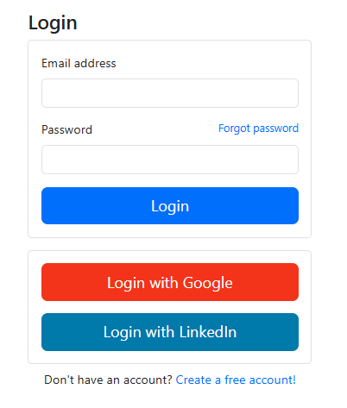

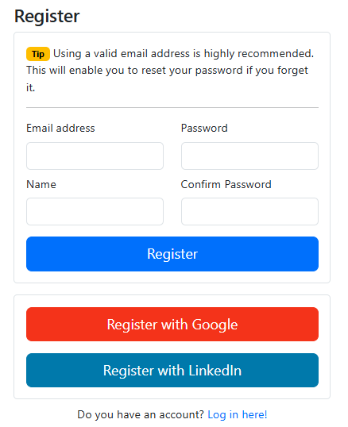

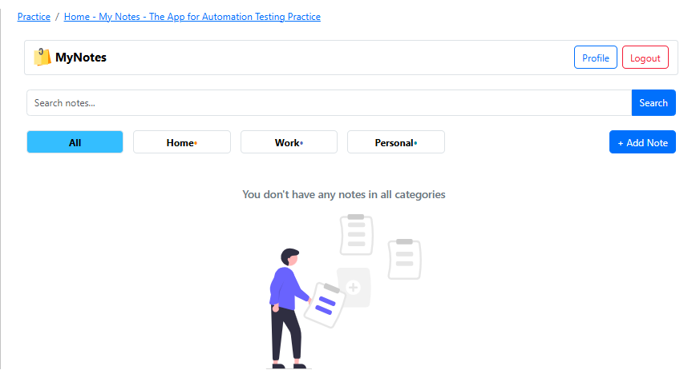

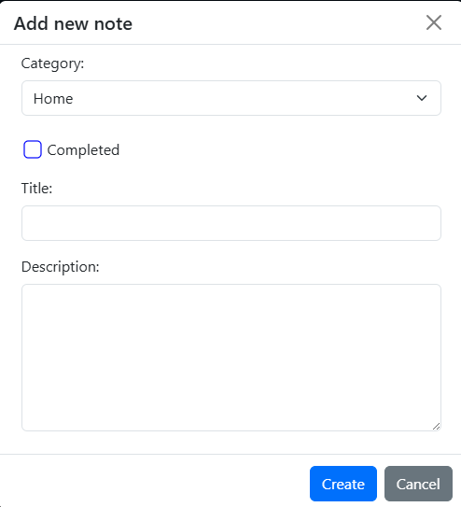

**Exclusion**

* Advanced admin panels or backend APIs (not user-facing).
* Integration with third-party services beyond social logins (e.g., no external storage sync).
* Load/stress testing for >1000 concurrent users.

**Test Environments**

The following environments will be used to simulate real-world usage:

* **Operating Systems and Versions:**
  + Windows 10 (64-bit)
  + Android 13+
* **Browsers and Versions:**
  + Google Chrome
  + Mozilla Firefox
  + Microsoft Edge
* **Device Types and Screen Sizes:**
  + Desktop: 1920*1080.
  + Laptop: 1366*768.
  + Smartphone: Android Galaxy A23 (1080*2408).
* **Network Connectivity:**
  + Wi-Fi (stable, 50 Mbps+).
  + Cellular (3G/4G simulation for mobile).
  + Wired Ethernet for desktop.
* **Hardware Requirements:**
  + Processor: Intel i5 11th Gen.
  + Memory: 8GB RAM.
  + Storage: 256GB SSD.
* **Security:**
  + HTTPS access only.
  + Authentication via app credentials/tokens.
* **Access Permissions:**
  + Testers: Read/write to test data.
  + Developers: Full access for fixes.
  + Stakeholders: View-only reports.

**Test Strategy**

**Step 1: Test Case Development**

* Create scenarios/cases for all modules using techniques:
  + Equivalence Class Partitioning.
  + Boundary Value Analysis.
  + Decision Table Testing.
  + State Transition Testing.
  + Use Case Testing.
* Apply expertise: Error Guessing, Exploratory Testing.
* Prioritize cases.

**Step 2: Testing Procedure**

* **Smoke Testing:** Verify basic flows (e.g., login → create note). Reject unstable builds.
* **In-Depth Testing:** Execute prioritized cases on multiple environments simultaneously.
* **Types of Testing:**
  + Smoke/Sanity.
  + Regression/Retesting.
  + Usability, Functionality, UI.
* Report daily defects via JIRA and email.
* Repeat cycles until quality threshold met.

**Step 3: Best Practices**

* **Context-Driven Testing:** Tailor to notes app context (e.g., mobile-first).
* **Shift-Left Testing:** Early reviews of designs/test cases.
* **Exploratory Testing:** Ad-hoc sessions for edge cases.
* **End-to-End Testing:** Full flows (e.g., register → note lifecycle → logout).

**Test Deliverables:**

* Test Cases (Excel).
* Test Plan (MS-Word).

**Entry and Exit Criteria**

**Requirement Analysis**

* **Entry:** Requirements documents received.
* **Exit:** Requirements understood; doubts cleared.

**Test Execution**

* **Entry:** Test cases signed off; stable build available.
* **Exit:** Test reports ready; defects <5% open.

**Test Closure**

* **Entry:** Reports ready.
* **Exit:** Final report obtained.

**Approvals**

| **Document** | **Approved By** | **Date** | **Signature** |
| --- | --- | --- | --- |
| Test Plan |  |  |  |
| Test Scenarios |  |  |  |
| Test Cases |  |  |  |

**Remarks:**